MULTIPLICATION OF NUMBERS

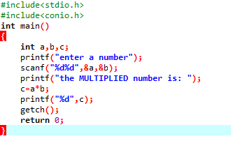

OUTPUT

